Chapter 12.11 Lab: Managing Networking

Marko Shaffer

Information Technology, Franklin University

ITEC 200: Linux Fundamentals

Professor Kagan Ulucay

7/13/2023

**Red Hat System Administration I 8.2**

**CH 12.11 Lab: Managing Networking**

# ****Performance Checklist****

# ****In this lab, you will configure networking settings on a Red Hat Enterprise Linux server. Outcomes****

**You should be able to enable, disable, start, and stop services.**

# ****Log in to workstation as student using student as the password.****

|  |  |  |  |
| --- | --- | --- | --- |
|  | Franklin VM: | Standard User Account: | The Student's Root Account: |
| Username | kiosk | student | root |
| Password | redhat | student | redhat |

<https://franklin.instructure.com/courses/12488/modules/items/683350>

[kiosk@foundation0 ~]$ rht-vmctl start all

[kiosk@foundation0 ~]$ rht-vmview view workstation

# ****Start Lab****

From workstation run the **lab net-review start** command. The command runs a start script that determine if the host, serverb, is reachable on the network.

**[student@workstation ~]$ lab net-review start**

## 

## Use the ssh command to log in to serverb as the student user. The systems are configured to use SSH keys for authentication, so a password is not required to log in to serverb.

**[student@workstation ~]$ ssh student@serverb**

*...output omitted...*

**[student@serverb ~]$**

## Use the sudo -i command to switch to the root user. If prompted, use student as the password.

**[student@serverb ~]$ sudo -i**

**[sudo] password for student: student**

**[root@serverb ~]#**

## 

## Create a new connection with a static network connection using the settings in the table.

| **Parameter** | **Setting** |
| --- | --- |
| Connection name | lab |
| Interface name | en*X* (might vary, use the interface that has 52:54:00:00:fa:0b as its MAC address) |
| IP address | 172.25.250.11/24 |
| Gateway address | 172.25.250.254 |
| DNS address | 172.25.250.254 |

Determine the interface name and the current active connection's name. The solution assumes that the interface name is en*X* and the connection name is Wired connection 1.

**[root@serverb ~]# ip link**

1: lo: <LOOPBACK,UP,LOWER_UP> mtu 65536 qdisc noqueue state UNKNOWN group default qlen 1000

link/loopback 00:00:00:00:00:00 brd 00:00:00:00:00:00

2: **en*X***: <BROADCAST,MULTICAST,UP,LOWER_UP> mtu 1500 qdisc fq_codel state UP group default qlen 1000

link/ether **52:54:00:00:fa:0b** brd ff:ff:ff:ff:ff:ff

**[root@serverb ~]# nmcli con show --active**

NAME UUID TYPE DEVICE

**Wired connection 1** 03da038a-3257-4722-a478-53055cc90128 ethernet en***X***

## Create the new lab connection profile based on the information in the table described in the instructions. Associate the profile with your network interface name listed in the output of the previous ip link command.

**[root@serverb ~]# nmcli con add con-name lab ifname en*X* type ethernet \**

**ipv4.method manual \**

**ipv4.address 172.25.250.11/24 ipv4.gateway 172.25.250.254**

**[root@serverb ~]# nmcli con mod "lab" ipv4.dns 172.25.250.254**

## 

## Configure the new connection to be autostarted. Other connections should not start automatically.

**[root@serverb ~]# nmcli con mod "lab" connection.autoconnect yes**

**[root@serverb ~]# nmcli con mod "Wired connection 1" connection.autoconnect no**

## 

## Modify the new connection so that it also uses the address 10.0.1.1/24.

**[root@serverb ~]# nmcli con mod "lab" +ipv4.addresses 10.0.1.1/24**

Or alternately:

**[root@serverb ~]# echo "IPADDR1=10.0.1.1" \**

**>> /etc/sysconfig/network-scripts/ifcfg-lab**

**[root@serverb ~]# echo "PREFIX1=24" >> /etc/sysconfig/network-scripts/ifcfg-lab**

## 

## Configure the hosts file so that 10.0.1.1 can be referenced as private.

**[root@serverb ~]# echo "10.0.1.1 private" >> /etc/hosts**

## 

## Reboot the system.

**[root@serverb ~]# systemctl reboot**

Connection to serverb closed by remote host.

Connection to serverb closed.

**[student@workstation ~]$**

## 

## From workstation use the ping command to verify that serverb is initialized.

**[student@workstation ~]$ ping -c3 serverb**

PING serverb.lab.example.com (172.25.250.11) 56(84) bytes of data.

64 bytes from serverb.lab.example.com (172.25.250.11): icmp_seq=1 ttl=64 time=0.478 ms

64 bytes from serverb.lab.example.com (172.25.250.11): icmp_seq=2 ttl=64 time=0.504 ms

64 bytes from serverb.lab.example.com (172.25.250.11): icmp_seq=3 ttl=64 time=0.513 ms

--- serverb.lab.example.com ping statistics ---

3 packets transmitted, 3 received, 0% packet loss, time 78ms

rtt min/avg/max/mdev = 0.478/0.498/0.513/0.023 ms

**[student@workstation ~]$**

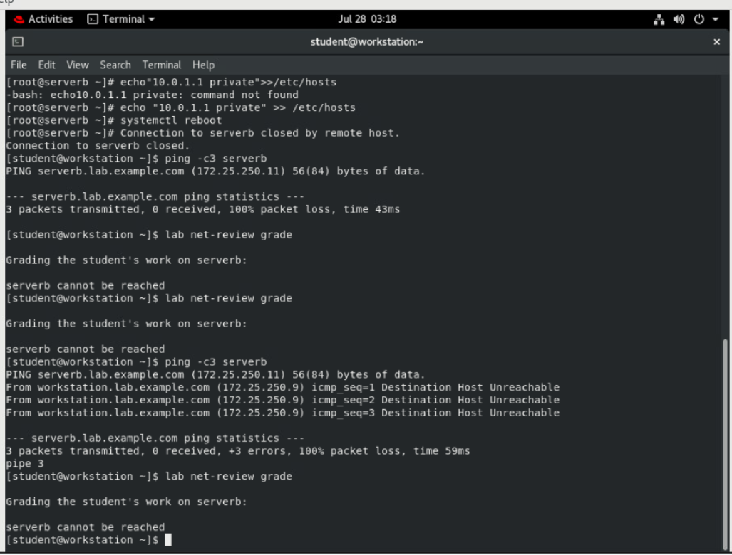

# Evaluation

On workstation, run the **lab net-review grade** script to confirm success on this lab.

**[student@workstation ~]$ lab net-review grade**



# Finish

On workstation, run the **lab net-review finish** script to finish this lab.

**[student@workstation ~]$ lab net-review finish**

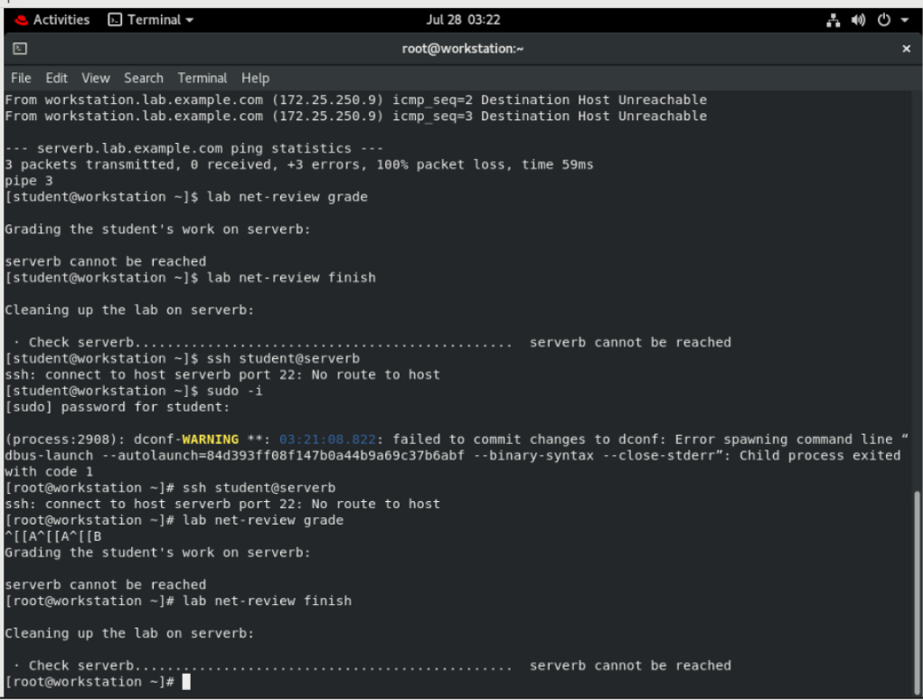

This concludes the lab.